Celebrate Commencement Week
By Joining Us For A Cruise of the Boston Harbor

Monday, May 24, 2010
Boarding at 11pm World Trade Center
Sailing From 11:30pm – 1:30am

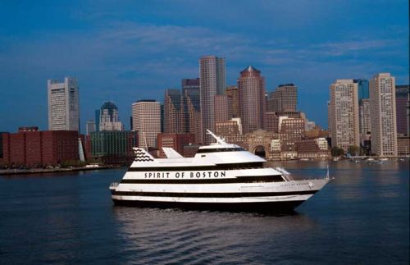

Tickets $45 Per Person
Includes 2 Free Drinks, Moonlight Buffet, And DJ Entertainment On Our Own Private Deck

To Purchase Tickets Please Email sheenaburke@gmail.com

